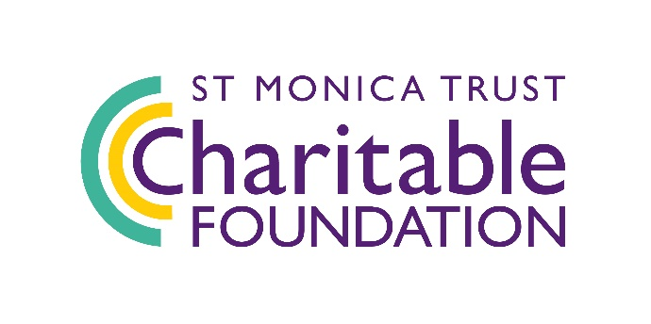**Volunteering and Employment**

**for Older People Fund**

**Expression of Interest**

Pleasetell us about yourselves and the work you would like us to fund.

1. **Organisation contact details**

|  |  |
| --- | --- |
| Organisation: |  |
| Contact name: |  |
| Job title: |  |
| Address: |  |
|
|
| Postcode: |  |
| Phone number: |  |
| Email: |  |
| Website: |  |

1. **About your organisation**

|  |  |  |
| --- | --- | --- |
| Please tell us in one sentence what the main work of your organisation is: | | |
| What type of organisation are you? | | |
| Registered charity | □ | Number: |
| Charitable club or incorporated association | □ | |
| Community Interest Company or social enterprise | □ | |
| Other (please specify) |  | |
| Number of employees: |  | |
| Number of volunteers: |  | |
| Number of trustees and or non-executive directors on your board: |  | |
| Most recent accounting year’s annual turnover: |  | |
| Please tell us why the cost of this project/activity cannot be met using your organisation’s existing funds: | | |

1. **Your proposal**

|  |
| --- |
| **What is the name of the project / activity you would like the St Monica Trust to support?** |
| **Which geographical location/s will the project cover?** |
| **How much funding are you applying for?** |
| **What would you like the St Monica Trust to fund?** (max 150 words)  *Please provide a brief outline of the project stating whether it is a new or existing project, and how our funds will be used.* |
| **What is the change you are aiming to achieve and how is your organisation well placed to deliver it?** (max 150 words)  *How will you make the change happen? Why is your organisation best placed to deliver it? (Refer to the fund overview and give specifics on the project, not your organisation as we can get this information from your website).* |

You can submit your Expression of Interest via email to [charitableimpact@stmonicatrust.org.uk](mailto:charitableimpact@stmonicatrust.org.uk) or alternatively you can post the form to: St Monica Trust, Charitable Impact, Cote Lane, Westbury-on-Trym, Bristol, BS9 3UN.

**Deadline for Expressions of Interest is midday Friday 01 November.**

If you have any questions, please contact us on 0117 949 4003.

The data collected on this form will only be processed in conjunction with St Monica Trust charitable funding. You can learn more about how we process and store information by reading our Privacy Policy here: [www.stmonicatrust.org.uk/privacy-policy](http://www.stmonicatrust.org.uk/privacy-policy).