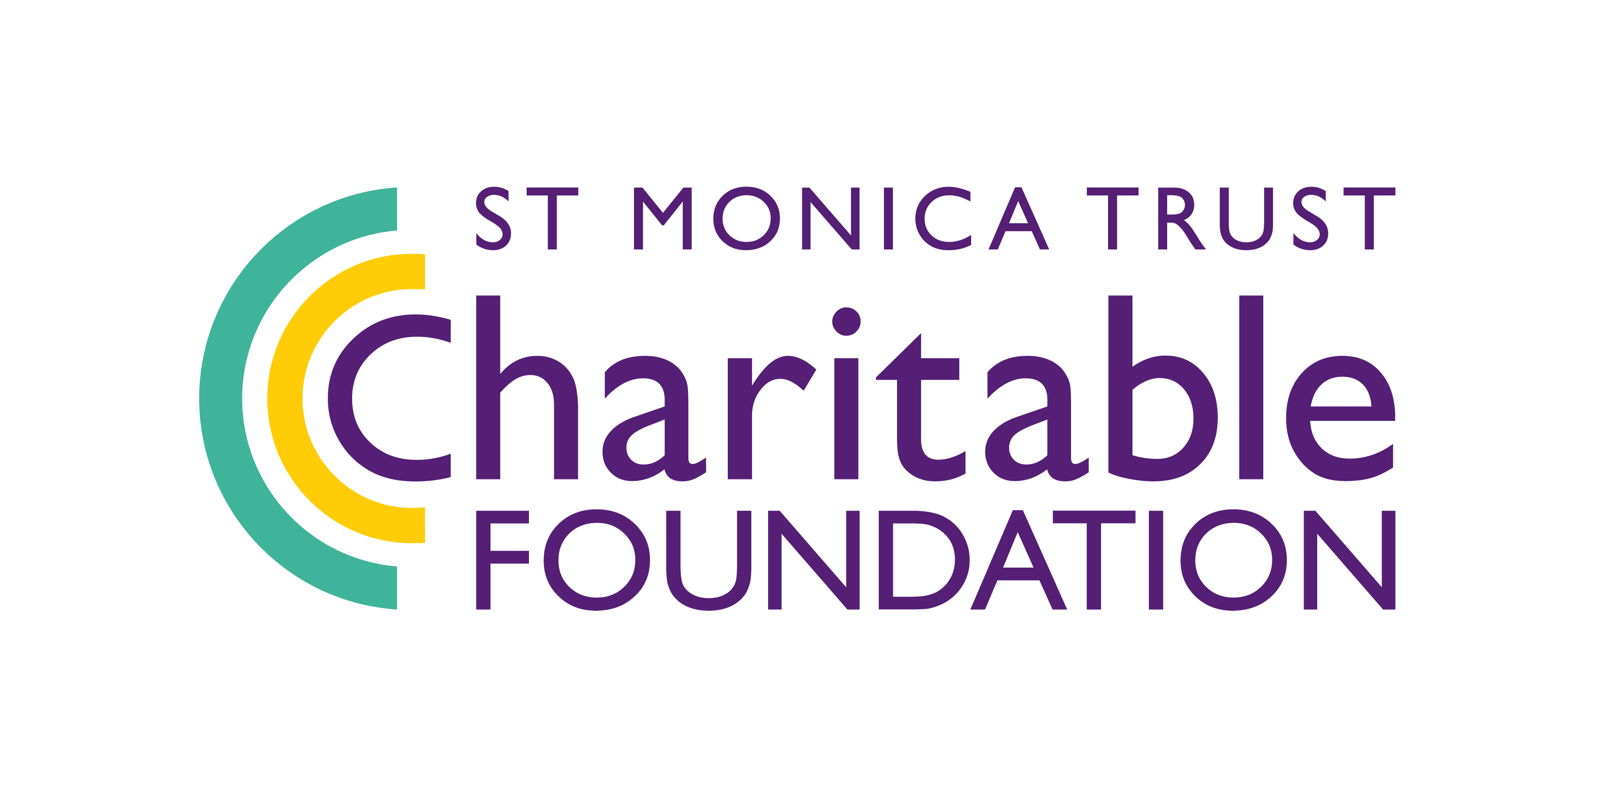**Core Fund**

**Expression of Interest**

Pleasetell us about yourselves and the core costs you would like us to fund.

1. **Organisation contact details**

|  |  |
| --- | --- |
| Organisation: |  |
| Contact name: |  |
| Job title: |  |
| Address: |  |
|
|
| Postcode: |  |
| Phone number: |  |
| Email: |  |
| Website: |  |

1. **About your organisation**

|  |  |  |
| --- | --- | --- |
| Please tell us in one sentence what the main work of your organisation is: | | |
| What type of organisation are you? | | |
| Registered charity |  | Number: |
| Charitable club or incorporated association |  | |
| Community Interest Company or social enterprise |  | |
| Other (please specify) |  | |
| Which geographical locations do your organisation cover? |  | |
| What percentage of your beneficiaries are over the age of 55? |  | |
| Most recent accounting year’s annual turnover: |  | |
| What is your reserves policy? |  | |
| Do you have a current safeguarding policy? |  | |

1. **Your proposal**

|  |
| --- |
| **What core costs would you like the St Monica Trust to fund?** (max 150 words) |
| **How much funding are you applying for?** |
| **How will core funding support the overall stability or development of your organisation?** (max 150 words) |
| **How will core funding enable you to foster innovation and/or expand your impact?** (max 150 words) |
| **How will core funding help your organisation to strengthen your future sustainability?** (max 150 words) |

You can submit your Expression of Interest via email to [charitableimpact@stmonicatrust.org.uk](mailto:charitableimpact@stmonicatrust.org.uk) or alternatively you can post the form to: St Monica Trust, Charitable Impact, Cote Lane, Westbury-on-Trym, Bristol, BS9 3UN.

**Deadline for Expressions of Interest is midday Friday 27 June 2025.**

If you have any questions, please contact us on 0117 949 4003.

The data collected on this form will only be processed in conjunction with St Monica Trust charitable funding. You can learn more about how we process and store information by reading our Privacy Policy here: [www.stmonicatrust.org.uk/privacy-policy](http://www.stmonicatrust.org.uk/privacy-policy).

