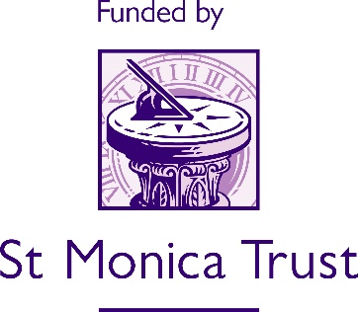

HEATING SYSTEM REPLACEMENT PROJECT

We recognise that having adequate heating and hot water are probably the most essential basic requirements for everyone, but particularly for older, vulnerable people.

Having noticed a decline in grant requests for boiler replacements and subsequently identifying that there was a shortfall in funding, we were keen to facilitate a solution.

As a result, we are delighted to announce that The Anchor Society and St Monica Trust have agreed a joint match-funding project on grants for heating system replacements and repairs in the Bristol area. Initially just for the repair or replacement of gas boilers, the project can now include other heating systems such as electric storage heaters.

To qualify, the applicant must meet the following criteria:
- Be age 55+
- Live in Bristol, South Gloucestershire, North Somerset, or Bath & North East Somerset
- Have a physical health issue/disability or mental health problem
- Be unable to afford to pay for the heating system due to financial circumstances (e.g. low income/limited or no savings)
Anchor will administer the grant applications, on behalf of both partners.

Applications should be submitted by a known third party referrer, utilising the Grant Request Form on The Anchor Society website: https://www.anchorsociety.co.uk/grants/

