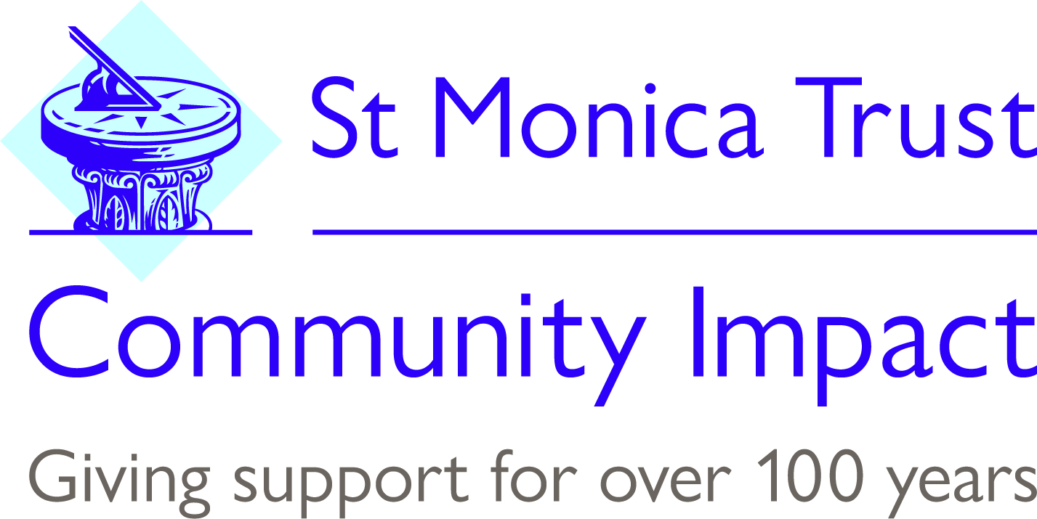

St Monica Trust Community Giving

Application Form for Organisations

Living Well Fund 2020:

St Monica Trust is keen to support projects and activities that can show they are supporting older people to be proactive about their health and wellbeing. For example by providing community activities, volunteering opportunities or helping people to stay in their own home.

Organisations can apply for up to £30,000 pa for up to three years (subject to annual reviews).

1. | Contact Details
 | Name:
 | Position:
 | Organisation:
 | Address:
 | Postcode:
 | Phone number:
 | Email:
 | Website:
2. | About your organisation
 | What are the aims and objectives of your organisation?
 | Briefly describe your main activities:
 | Which area(s) do you cover? (please tick all that apply)
 | Bristol |  |  |  | □ |  | South Gloucestershire |  | □
 | Bath & North East Somerset |  |  |  | □ |  | Other (please specify) |  | □
 | North Somerset |  |  |  | □ |  |  |  | □
 | How would you describe your organisation?
 | Registered charity |  |  |  |  | □ |  | Number:
 | Self-help group |  |  |  |  | □
 | Branch of a national charity |  |  |  |  | □
 | Other (please specify) |  |  |  |  | □
 | Current free reserves
 | Organisations annual income for the past financial year
 | How many of the following are involved in your organisation/group:
 | Full time staff
 | Part time staff
 | Management committee/board
 | Volunteers (excluding Board)
3. |  | About your request
3.1. |  | Purpose
 |  | Please provide a summary of the project you would like the St Monica Trust to fund:
How much are you requesting:

Year One:

Year Two:

Year Three:
 |  | Does the project include older people in the planning and delivery of it?
 |  | If this is not a new project, please provide details on how long the project has been running for and how it has been previously been funded.
 |  | How does the project encourage older people to be proactive about their health and wellbeing?
 |  | Is the project sustainable? – If not please explain why not and how this will be addressed long term.
 |  | Is the project unique to the location? If not how does it differ to other work/projects? Is there any collaboration?
Please tell us up to three specific outcomes (in relation to the five ways to wellbeing – Connect, Be Active, Take Notice, Learn and Give) you expect to deliver as a result of this funding:

1.

2.

3.

3.2. |  | Costs
 |  | Please provide a three year budget for the project. (Year one to be a detailed budget with an indicative budget for years two and three).
 |  | If you are not asking the St Monica Trust for the full amount, how will you / how have you secured the rest of the money needed?
 |  | Any other information that you wish to include in support of your application?
4. | Signature of Applicant
 | Signature:
 | Position:
 | Organisation:
 | Date:

Please return this application form to: Angelina Shoemake,
Community Giving Manager, St Monica Trust Community Fund, Cote Lane, Westbury on Trym, Bristol BS9 3UN (Closing Date Midday 15th April 2020).

We will acknowledge receipt of your application in writing. We may then contact you for further information.

If any significant changes occur that affect/impact on your organisation’s ability to deliver the service you are seeking funding for, please do keep us informed as this may affect our decision to award a grant, e.g. you have been awarded funding from another source or have had funding reduced or withdrawn.

