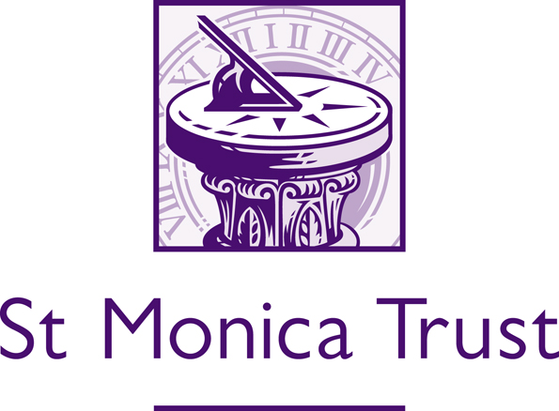

St Monica Trust Community Giving application form for organisations

Mental Health & Older People Fund 2021:

Please read the Mental Health & Older People Fund Guidance and the Monitoring Impact Overview before completing the application form

The aim of the Mental Health & Older People Fund is to support organisations to address the growing issue of older people experiencing mental health issues, especially those that have been affected by the pandemic.

The St Monica Trust will provide five organisations with up to £45,000 for eighteen months to deliver a project supporting older people and addressing issues around mental health. Organisations applying must have been constituted for a minimum of 12 months and be able to provide financial accounts.

Our funding may be used to develop new mental health projects or to strengthen and expand existing provision. We are looking to fund projects that engage with people over the age of 55, addresses inequalities and work collaboratively with the organisations and the community.

For this funding, we are specifically interested in funding mental health projects that can improve people’s mental health and general quality of life within Bristol, BANES, South Gloucestershire and/or North Somerset.

Applications should demonstrate older people’s involvement with shaping the project, and consideration of sustainability and longevity.

1. | Contact Details
 | Name:
 | Position:
 | Organisation:
 | Address:
 | Postcode:
 | Phone number:
 | Email:
 | Website:
2. | About your organisation
 | What are the aims and objectives of your organisation and the activities/services that your organisation provides? (200 words)
 | How would you describe your organisation?
 | Registered charity |  |  |  | □ | Number:
 | Charitable club or incorporated association |  |  |  | □
 | Community Interest Company |  |  |  | □
 | Other (please specify) |  |  |  | □
3. |  | About your proposal
3.1. |  | Purpose
 |  | Please provide a summary of the mental health project you would like the St Monica Trust to fund. (Guide 500 words)
 |  | How have older people been involved in the development of the project? (Guide 300 words)
 |  | Are you collaborating with any other organisations on this project? Please give details. (Guide 300 words)
 |  | What is the evidence that this is needed? How it will have a positive outcome for the participants. (Guide 300 words)
 |  | How many older people will benefit from the project? Please explain how you came to this figure. (Guide 150 words)
 |  | How will the sustainability of the project be addressed? What elements will be implemented/considered to ensure sustainability? (Guide 150 words)
Outcomes:

All successful projects will be asked to collect 4 indicators that show the impact that the project has had on participants. You can see our 6 outcomes in the Monitoring Impact Overview, but for this fund we are most interested to see the impact on the following two outcomes:

Security and Independence

People feel safe in their homes and communities and feel that they have control over their everyday life.

Well-being and Spirituality

People with a religious belief or none are happy and can look after their emotional and spiritual needs.

Please tell us which 4 indicators you plan to collect. At least 2 of the indicators must contribute to the above outcomes.

If applicable, please identify any other outcomes you will be measuring:

How will you measure the above outcomes? (Guide 150 words)

 |  | Please explain how you will address inequality in your community and/or promote diversity through this project. (Guide 150 words)
3.2. |  | Costs
 |  | How much will this work/project cost in total? |  |  |  |  | £
 |  | How much are you requesting from the St Monica Trust |  |  |  |  | £
 |  | Do you have any match funding/in kind resources identified? If yes, please provide details:
 |  | Please give details of any other funders you have also applied to for the same work/project:
Please provide an 18-month budget breakdown for the work/project:

Description | £

 |  | Any other information that you wish to include in support of your application? (Guide 250 words)
4. | Signature of Applicant
 | Signature:
 | Position:
 | Organisation:
 | Date:

Please email this application form to: charitableimpact@stmonicatrust.org.uk (Closing date: Midday, Friday 13th August 2021)

We will acknowledge receipt of your application by return email. We may then contact you for further information.

If any significant changes occur that affect/impact on your organisation’s ability to deliver the service you are seeking funding for, please do keep us informed as this may affect our decision to award a grant, e.g. you have been awarded funding from another source or have had funding reduced or withdrawn.

