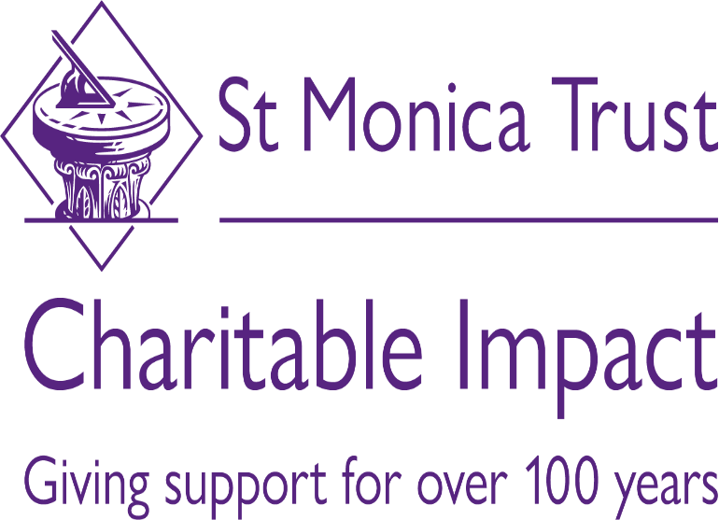

2021 Funding – Mental Health & Older People Fund
Guidance

‘Mental health is a state of well-being in which an individual realises his or her own abilities, can cope with the normal stresses of life, can work productively and is able to make a contribution to his or her community’ (World Health Organisation)

St Monica Trust - Community Giving
As we start to slowly emerge from lockdown and see a desire to return to ‘normal’, there is increasing concern around the impact lock down has had on older people’s physical and mental health and how this may impact in their ability to re-engage with society.
A recent study carried out by the Kings Fund states that there is a significant gap in mental health services for older people who are often poorly served.
There is already a lot of good work being carried out to help older people to re-engage with their community. However, after consulting and engaging with various stakeholders, there is a consensus that a more immediate challenge is to support older people who are suffering with mental health issues developed through lockdown, including anxiety, depression, and loss of confidence.
For a lot of people, this is something they have never had to deal with before, and often for the older generation something they struggle with, having the mind set of ‘keeping a stiff upper lip’.

Mental Health & Older People Fund 2021 – Guidance
Before applying to the Mental Health & Older People Fund, please read the following guidance.
A suggested word count is provided for each question.
What does the St. Monica Trust want to fund?
The St Monica Trust aims to fund projects that reach the most vulnerable older people living in Bristol, Bath & North East Somerset, South Gloucestershire and North Somerset.
We are looking for projects that address inequalities, support and empower older people to understand their mental health issues and to improve their overall quality of life.
Priority will be given to bids that:
- Empower older people

- Have a strong input from older people into the shaping of the project.

- Engage with other services and collaborative models such as the Bristol Support Hub or similar collective approaches.

- Connect with existing health provision.

- Address inequality and/or promote diversity through its delivery.

- Have considered sustainability and longevity of the project.
Funding
The St Monica Trust is looking to fund at least five organisations for up to £45,000. We have set a time frame of 18 months. This is to support enough time to establish a project with a target of 12 months plus of actual delivery.
Organisations must have been constituted for over 12 months and be able to supply financial records.

Outcomes
St. Monica Trust is interested to see the impact that our grant giving has on individuals who access the funded services. Our Monitoring Impact Overview sets out 6 outcomes that we hope to achieve for older people and when funding organisations we ask that they record evidence to contribute to one or more of these.
For the Older People’s Mental Health Fund, the Trust is interested to see the impact that the projects have on 2 of the outcomes:
- Security and Independence

People feel safe in their homes and communities and feel that they have control over their everyday life.
We believe mental health support through this fund will help people feel more positive and to feel more in control of their lives. Example indicators include:
- I know how to get help when I need it.
- I have the level of support I want.
- I feel in control of my life

- Well-being and Spirituality

People with a religious belief or none are happy and can look after their emotional and spiritual needs.
Mental well-being is a key factor in a good quality of life and will obviously be a core outcome of this fund. We are anticipating projects that focus on mental well-being, spirituality and mindful practices with indicators that might include:
- I have good mental health.
- I feel satisfied with my life.
- I have been feeling good about myself

We will ask for successful projects to collect at least 4 indicators with at least 2 coming from the above outcomes. Participants should be asked to score these indicators on a scale of 1 (Totally Disagree) – 10 (Totally Agree) at the beginning of the project and at the end. You can suggest the outcomes that you would like to collect in the application, but these will be formally agreed when the grant is made.

Guidance On The Application

About Your Organisation (Guide 200 words).
- Provide a general description of your organisation and its aims and objectives.

- Who are the main beneficiaries of the work you do?
A summary of the project to be funded (Guide 500 words)
- Please provide a brief but clear description of the project.

- Is this a new project or an expansion of an ongoing one?

- If it is an expansion of a project, please provide evidence/business case for the need of an expansion.
What geographical area does the activity cover?
- The activity MUST be held within Bristol, South Gloucestershire, Bath & North East Somerset or North Somerset.

- We will not consider applications where the activity is outside of the above mentioned areas.
Collaboration (Guide 300 words)
- Priority will be given to projects that work collaboratively with other services and organisations in their region.

- If you are collaborating, please clarify who with and how.

- Do not just list organisations that you might engage with or that you only know of
What is the evidence this is needed? How will it have a positive outcome for the participants? (Guide 300 words)
- Provide any evidence you can that shows why there is a need for this service with your target audience, or target location e.g. previous reports, case studies. You may also wish to share evidence that supports your proposed model.

How many older people will this benefit? (Guide 150 words)
- Be realistic, however we understand that this is an estimation.

- How many people are you anticipating will benefit from this project? It would be useful to understand if these are new or existing participants, and how long you expect their engagement to be e.g. are you running one-off events or are participants expected to come to multiple sessions?

- How many interactions or number of sessions are you expecting to hold?

- Please explain how you came to these numbers, providing any evidence you feel is necessary to support this estimate.

How have older people been involved in the development of this idea? How will they continue to be involved? (Guide 300 words)
- Evidence how older people are involved.

- If not, how can older people influence and impact the project?

Sustainability (Guide 150 words)
- What elements will be considered/implemented to ensure sustainability

- Applications that are totally reliant on finding future funding will not be given priority

Outcomes (Guide 150 words)
- St. Monica Trust is interested in seeing how participants are better off from the projects proposed by measuring certain indicators.
- We have identified two outcomes from which we would like to see indicators measured:
  - Security and Independence e.g.
    - I know how to get help when I need it
    - I have the level of support I want
    - I feel in control of my life

  - Well-being and Spirituality
    - I have good mental health.
    - I feel satisfied with my life.
    - I have been feeling good about myself

- We would like 4 indicators measured with at least 2 that contribute to the above outcomes. In the application you should identify what 4 indicators you will collect.

- How will you measure these indicators of the project?

- Successful applications will have an initial meeting with the Community Giving Manager to agree on indicators for the outcomes, measuring methods and report requirements.

Please provide a detailed budget
- Constituted groups may apply for up to £45,000 for eighteen months

- Provide a clear, concise and realistic budget

- Provide details of any match funding – including ‘in kind’

The deadline for applications is Midday - Friday 13th August 2021. You can submit the application via email to charitableimpact@stmonicatrust.org.uk.
If you have any questions regarding the Mental Health Fund, please email charitableimpact@stmonicatrust.org.uk
Successful organisations will be notified by Friday 20th August 2021.

