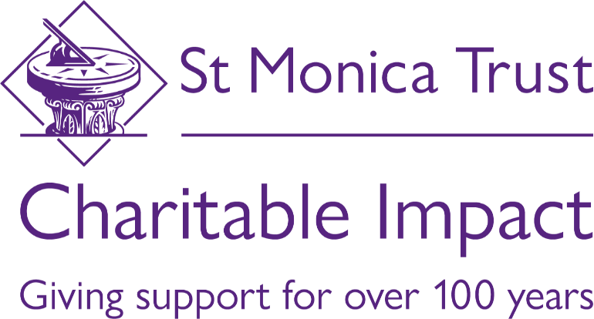

Monitoring Impact Overview
- Introduction
St Monica Trust has been operating for more than 100 years and provides over £1million a year to individuals and organisations working with older people. We are committed to improving the quality of life of older people in the region and want to see who is better off from the funding that we can provide.

In order to see the long-term impacts of our funding, we want to work with our beneficiaries to monitor what outcomes our investments have for older people in Bristol, Bath and North East Somerset, North Somerset and South Gloucestershire.

Working with individuals, voluntary and community sector organisations and other stakeholders, we have developed an outcomes framework that represents what we consider to be core element of someone’s quality of life.
- Security and Independence
People feel safe in their homes and communities and feel that they have control over their everyday life.
- Well-being and Spirituality
People with a religious belief or none are happy and feel supported in looking after their emotional and spiritual needs.
- Respect and Inclusion
People from all backgrounds and ethnicities feel respected by those around them and feel able to access and engage with services.

- Fitness and Healthy Life
People are regularly physically active and able to contribute to their own good health.
- Belonging and Community Contributions
People feel part of a community and can contribute to their communities through participation at events, volunteering, or other community action.
- Creativity and Learning
People can continue to thrive, learn and be inspired.

- Measuring Outcomes
The outcomes and their descriptions represent long term goals for the Trust’s charitable impact work and, going forward, everything that we do should align to one or more outcomes.
In order to evidence our contributions to these outcomes, we will monitor a range of specific indicators under each which will help us see how older people are better off from our work.

- Indicators
While we are keen to see the outcomes of our funding, we also want to work with our funded partners to find the most useful ways of evidencing this. When awarding new grants, we will work with partners to agree appropriate indicators that work for both of us and showing the benefit to older people. The indicators may be new or existing, but for ease, we will try to rationalise similarly worded indicators across our funded partners.

Participants will be asked to rate each indicator on a scale of 1 (Totally Disagree) to 10 (Totally Agree) and depending on the project and size of our award, we might ask for this once, or at the start and end of the person’s involvement with the project.

Below is a list of indicators that we have previously identified and are already used by other organisations. These are just examples and we would be happy to consider others if funded partners are already using others.

- Security and Independence - People feel safe in their homes and communities and feel that they have control over their everyday life.
- I feel safe in my community.
- I feel financially secure.
- I know how to get help when I need it.

- Well-being and Spirituality - People feel happy and supported in looking after their emotional and spiritual needs, however they may be expressed.
- I feel happy.
- My spiritual needs are met.
- I have been feeling confident.
- I feel satisfied in my life.
- I have been feeling good about myself.

- Respect and Inclusion - People from all backgrounds and ethnicities feel respected by those around them and feel able to access and engage with services.
- I feel recognised and appreciated.
- I do not feel my age is a barrier.
- I can easily engage with things I want to.

- Fitness and Healthy Life - People are regularly physically active and able to contribute to their own good health.
- I can access suitable physical activities that I want to do.
- Activity levels have increased.
- I know how much physical activity I need to do to stay healthy, and regularly achieve this.
- I have noticed an improvement in my physical well-being.

- Belonging and Community Contributions - People feel part of a community and can contribute to their communities through engagement with events, volunteering, or other community action.
- I feel recognised and appreciated.
- I get the level of social contact that I want.
- I can contribute to my community as much as I want to.
- I feel needed/useful.
- I have people I can talk to.

- Creativity and Learning - People can continue to thrive, learn and be inspired.
- I have been able to do the things that I want to do.
- I have opportunities and a sense of purpose.
- I have been engaging with people who have similar interests.
- I feel inspired.

- Agreeing Indicators
When you apply to the St. Monica Trust, we will let you know which of our 6 outcomes we hope to contribute to through the award. In the application form you will be asked to identify the indicators you would collect if successful. When we approve funds, our Community Giving Manger will contact you to sign a grant agreement and agree the indicators that you will collect.

We may ask you to confirm age and locations of participants, but this will always be totals for all participants and we will not ask for personal details.

